K L UNIVERSITY
FRESHMAN ENGINEERING DEPARTMENT

A Project Based Lab Report On

SMART CAMPUS NAVIGATION, FACILITY MONITORING & RESOURCE ANALYTICS SYSTEM (SCN-FMRA)

SUBMITTED BY:
ID NUMBER NAME
2500030038 P. Tanvika

UNDER THE ESTEEMED GUIDANCE OF Dr. N. SREE RAM
ASSISTANT PROFESSOR



KL UNIVERSITY
Green fields, Vaddeswaram – 522 502 Guntur Dt., AP, India.

DEPARTMENT OF BASIC ENGINEERING SCIENCES



CERTIFICATE

This is to certify that the project based laboratory report entitled “SMART CAMPUS NAVIGATION, FACILITY MONITORING & RESOURCE ANALYTICS SYSTEM (SCN-FMRA)” submitted by, P.Tanvika ,bearing Regd. No. 2500030038, to the Department of COMPUTER SICENCE ENGINEERING , KL University in partial fulfillment of the requirements for the completion of a project based Laboratory in “python programming (25SC2007)” course in I B Tech II Semester, is a Bonafede record of the work carried out by them under my supervision during the academic year 2025 – 2026.

PROJECT SUPERVISOR HEAD OF THE DEPARTMENT Dr. N. SREE RAM Dr. D. HARITHA

ACKNOWLEDGEMENTS

It is great pleasure for me to express my gratitude to our honorable President.

Sri. Koneru Satyanarayana, for giving the opportunity and platform with facilities in accomplishing the project-based laboratory report.
I express sincere gratitude to our Director Dr. A. Jagdeesh for his administration towards our academic growth.
I express sincere gratitude to our Coordinator and HOD-BES Dr. D. Haritha for her leadership and constant motivation provided in successful completion of our academic semester. I record it as my privilege to deeply thank you for providing us with the efficient faculty and facilities to make our ideas into reality.
I express my sincere thanks to our project supervisor Dr. N. SREE RAM for his novel association of ideas, encouragement, appreciation, and intellectual zeal which motivated us to venture this project successfully.
Finally, we are pleased to acknowledge our indebtedness to all those who devoted themselves directly or indirectly to making this project a success.

Name: P. Tanvika

ID No: 2500030038

ABSTRACT

Smart Campus Navigation, Facility Monitoring & Resource Analytics System (SCN-FMRA)
The Smart Campus Navigation, Facility Monitoring & Resource Analytics System (SCN-FMRA) is a Python-based application designed to improve the efficiency and management of campus operations. The system integrates multiple functionalities such as campus navigation, facility booking, maintenance complaint tracking, asset management, and data analytics into a single platform.
The navigation module uses a graph-based approach with the Breadth-First Search (BFS) algorithm to help users find paths between different campus locations. The facility management and booking system allows users to add and reserve rooms while preventing scheduling conflicts. The complaint module enables users to report maintenance issues and track their status, while the asset management module helps in monitoring campus resources.
The system also incorporates data storage using JSON files and performs analytical operations using the Pandas library to generate insights such as facility usage patterns. Visualization is achieved using Matplotlib, which provides graphical representation of data for better understanding.
This project demonstrates the application of core Python concepts including data structures, object-oriented programming, file handling, and data analysis in solving real-world problems. The system provides a scalable foundation for developing advanced smart campus solutions with future enhancements like web integration, artificial intelligence, and IoT-based automation.

KEYWORDS:

SCN-FMRA Project

- Smart Campus System
- Campus Navigation
- Facility Management
- Booking System
- Maintenance Management
- Asset Tracking
- Data Analytics
- Python Programming
- Breadth-First Search (BFS)
- JSON File Handling
- Pandas
- Matplotlib
- Data Visualization

INDEX

S.NO | TITLE | PAGE NO
1 | Introduction | 6
2 | Aim of the Project | 7
2.1 | Advantages & Disadvantages | 8
2.2 | Future Implementation | 8
3 | Software & Hardware Details | 9
4 | Data Flow Diagram | 10
5 | Algorithm for each module | 11-12
6 | Implementation | 13-18
7 | Integration and System Testing | 19-23
8 | Conclusion | 24

INTRODUCTION

The Smart Campus Navigation, Facility Monitoring & Resource Analytics System (SCN-FMRA) is an intelligent campus management solution developed using Python. This system aims to digitalize and optimize campus operations by integrating navigation, facility booking, maintenance tracking, asset management, and analytics into a single platform.

In modern universities, students and administrators face challenges such as locating facilities, managing room bookings, tracking maintenance issues, and analyzing resource utilization. This project provides a centralized system to address these problems efficiently.

The system uses core Python concepts like data structures, object-oriented programming, file handling, and data analytics libraries such as Pandas and Matplotlib to simulate a real-world campus environment.

AIM

The main aim of this project is to:

- Develop an intelligent system for campus navigation

- Provide a platform for facility booking and scheduling

- Enable maintenance complaint tracking

- Manage campus resources efficiently

- Generate analytical insights for decision-making

- Build a real-world application using Python
Advantages

- Centralized system for all campus operations
- Easy navigation using graph-based approach
- Prevents double booking of facilities
- Improves maintenance tracking efficiency
- Provides data-driven insights using analytics
- Scalable and modular design
- Helps students learn real-world software development

Disadvantages

- CLI-based interface (not user-friendly for non-technical users)
- Limited real-time tracking (no live GPS integration)
- Manual data entry required
- Basic security (no authentication system)
- Navigation is simplified (not real map-based)

FUTURE IMPLEMENTATION

The system can be enhanced with:
- GUI using Tkinter or PyQt
- Web-based application using Flask/Django
- Integration with real campus maps (Google Maps API)
- AI/ML-based prediction (room usage, maintenance forecasting)
- Mobile application development
- Real-time IoT integration (smart sensors)
- User authentication & role-based access
- Cloud storage and database integration (MySQL/Firebase)

SYSTEM REQUIREMENTS

SOFTWARE REQUIREMENTS:
The major software requirements of the project are as follows: Language:pycharm.
Operating system: Windows 10 or more.
Technical requirements: Monitor, CPU, Keyboard, Mouse, etc...

HARDWARE REQUIREMENTS:
The hardware requirements that map towards the software are as follows: RAM: 8 GB.
Processor: i5/i7.

DATA FLOW DIAGRAM

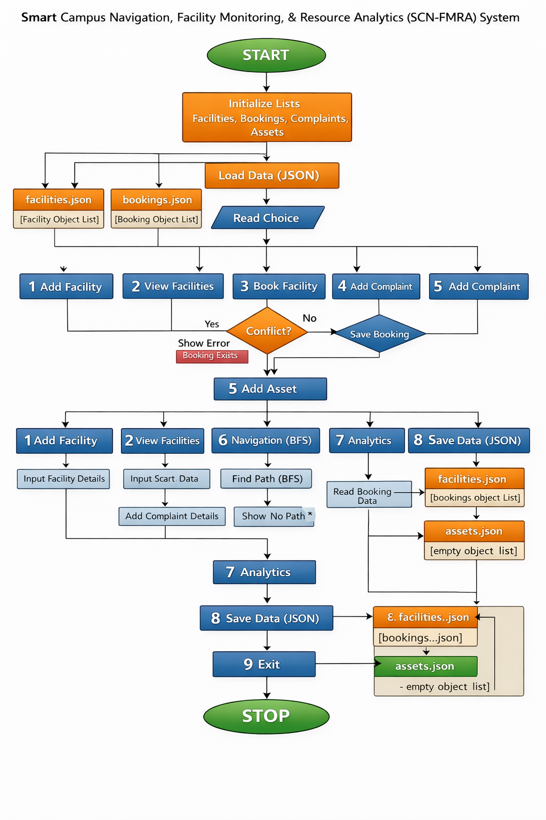

ALGORITHMS

🔹 1. Facility Management
- Start
- Enter facility details
- Check capacity > 0
- Store details in list
- Display facility
- Stop

🔹 2. View Facilities
- Start
- Read facility list
- Display all facilities
- Stop

🔹 3. Booking System
- Start
- Enter booking details
- Check if already booked
- If yes → show error
- Else → store booking
- Stop

🔹 4. Navigation (BFS)
- Start
- Enter start and destination
- Use queue to store paths
- Visit nodes one by one
- If destination found → show path
- Else → show no path
- Stop

🔹 5. Complaint System
- Start
- Enter complaint details
- Store in list
- Set status = Open
- Stop

🔹 6. Asset Management
- Start
- Enter asset details
- Store in list
- Display confirmation
- Stop

🔹 7. Save Data
- Start
- Convert data to JSON
- Save in file
- Stop

🔹 8. Load Data
- Start
- Read JSON file
- Convert to list
- Stop

🔹 9. Analytics
- Start
- Read booking data
- Count usage
- Display result
- Stop

🔹 10. Main Program
- Start
- Show menu
- Take user choice
- Call corresponding function
- Repeat until exit
- Stop

IMPLEMENTATION

import json
import os
from collections import deque
import pandas as pd
import matplotlib.pyplot as plt
# ---------------- DATA ----------------
facilities = []
bookings = []
complaints = []
assets = []
# ---------------- MODELS ----------------
class Facility:
def __init__(self, fid, building, room_type, capacity, floor, coordinates):
self.fid = fid
self.building = building
self.room_type = room_type
self.capacity = capacity
self.floor = floor
self.coordinates = coordinates
def to_dict(self):
return self.__dict__
def __str__(self):
return f"{self.fid} | {self.building} | {self.room_type} | {self.capacity}"
class Booking:
def __init__(self, facility_id, purpose, start, end):
self.facility_id = facility_id
self.purpose = purpose
self.start = start
self.end = end
def to_dict(self):
return self.__dict__
class Complaint:
def __init__(self, cid, facility_id, issue, severity, status="Open"):
self.cid = cid
self.facility_id = facility_id
self.issue = issue
self.severity = severity
self.status = status
def to_dict(self):
return self.__dict__
class Asset:
def __init__(self, aid, category, building, room, status):
self.aid = aid
self.category = category
self.building = building
self.room = room
self.status = status
def to_dict(self):
return self.__dict__
# ---------------- STORAGE ----------------
def save_data(filename, data):
with open(filename, "w") as f:
json.dump(data, f, indent=4)
def load_data(filename):
if not os.path.exists(filename):
return []
with open(filename, "r") as f:
return json.load(f)
def save_all():
save_data("facilities.json", [f.to_dict() for f in facilities])
save_data("bookings.json", [b.to_dict() for b in bookings])
print("Data Saved")
def load_all():
global facilities, bookings
facilities_data = load_data("facilities.json")
bookings_data = load_data("bookings.json")
facilities = [Facility(**f) for f in facilities_data]
bookings = [Booking(**b) for b in bookings_data]
# ---------------- NAVIGATION ----------------
campus_map = {
"E-Block": ["Library", "Admin"],
"Library": ["E-Block", "Canteen"],
"Admin": ["E-Block"],
"Canteen": ["Library"]
}
def bfs(start, goal):
queue = deque([[start]])
visited = set()
while queue:
path = queue.popleft()
node = path[-1]
if node == goal:
return path
if node not in visited:
visited.add(node)
for neighbor in campus_map.get(node, []):
queue.append(path + [neighbor])
return "No path found"
# ---------------- FEATURES ----------------
def add_facility():
fid = input("ID: ")
building = input("Building: ")
room_type = input("Type: ")
capacity = int(input("Capacity: "))
floor = int(input("Floor: "))
coordinates = tuple(map(int, input("Coordinates (x y): ").split()))
facilities.append(Facility(fid, building, room_type, capacity, floor, coordinates))
print(" Facility Added")
def view_facilities():
print("\n--- Facilities ---")
for f in facilities:
print(f)
def book_facility():
fid = input("Facility ID: ")
purpose = input("Purpose: ")
start = input("Start Time: ")
end = input("End Time: ")
for b in bookings:
if b.facility_id == fid and b.start == start:
print(" Booking Conflict!")
return
bookings.append(Booking(fid, purpose, start, end))
print(" Booked Successfully")
def add_complaint():
cid = input("Complaint ID: ")
fid = input("Facility ID: ")
issue = input("Issue: ")
severity = int(input("Severity (1-5): "))
complaints.append(Complaint(cid, fid, issue, severity))
print(" Complaint Added")
def add_asset():
aid = input("Asset ID: ")
category = input("Category: ")
building = input("Building: ")
room = input("Room: ")
status = input("Status: ")
assets.append(Asset(aid, category, building, room, status))
print(" Asset Added")
def navigate():
start = input("Start Location: ")
end = input("Destination: ")
print("Path:", bfs(start, end))
# ---------------- ANALYTICS ----------------
def analytics():
if not bookings:
print("No booking data")
return
df = pd.DataFrame([b.to_dict() for b in bookings])
result = df.groupby("facility_id").size()
print("\n--- Usage ---")
print(result)
result.plot(kind="bar")
plt.title("Facility Usage")
plt.xlabel("Facility")
plt.ylabel("Bookings")
plt.show()
# ---------------- MENU ----------------
def menu():
load_all()
while True:
print("\n===== SCN-FMRA SYSTEM =====")
print("1. Add Facility")
print("2. View Facilities")
print("3. Book Facility")
print("4. Add Complaint")
print("5. Add Asset")
print("6. Navigation")
print("7. Analytics")
print("8. Save Data")
print("9. Exit")
ch = input("Enter choice: ")
if ch == "1":
add_facility()
elif ch == "2":
view_facilities()
elif ch == "3":
book_facility()
elif ch == "4":
add_complaint()
elif ch == "5":
add_asset()
elif ch == "6":
navigate()
elif ch == "7":
analytics()
elif ch == "8":
save_all()
elif ch == "9":
save_all()
print("Exiting...")
break
else:
print("Invalid choice!")
# ---------------- RUN ----------------
if __name__ == "__main__":

menu()
INTEGRATION AND SYSTEM TESTING
OUTPUTS

Screen Shots:

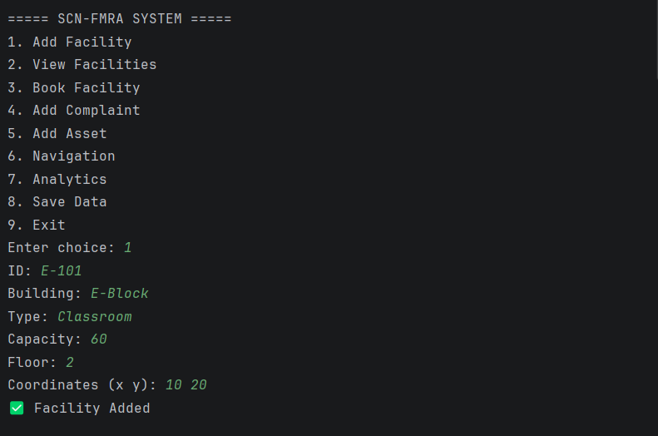

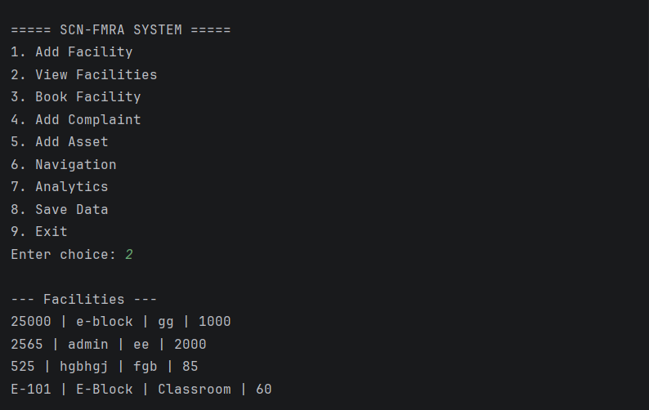
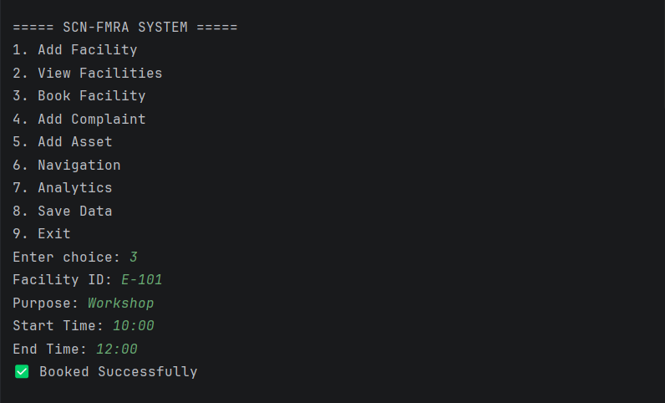

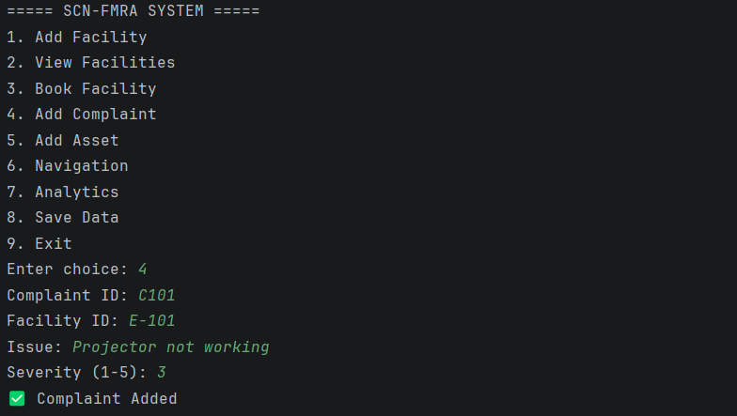

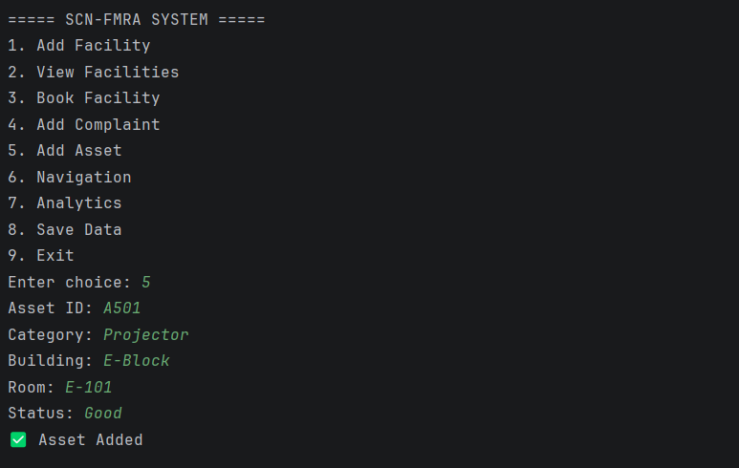

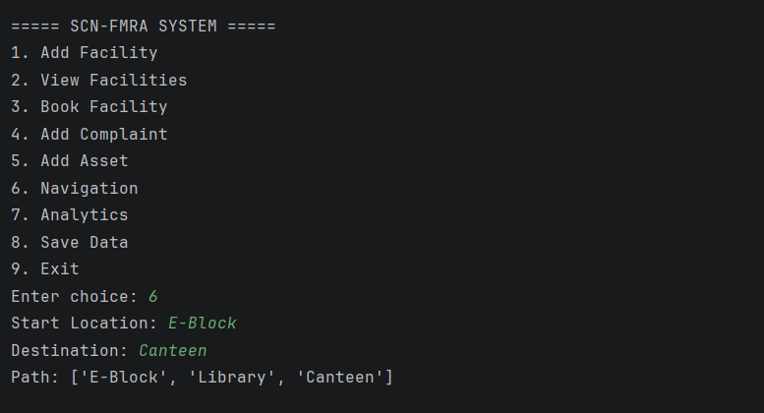
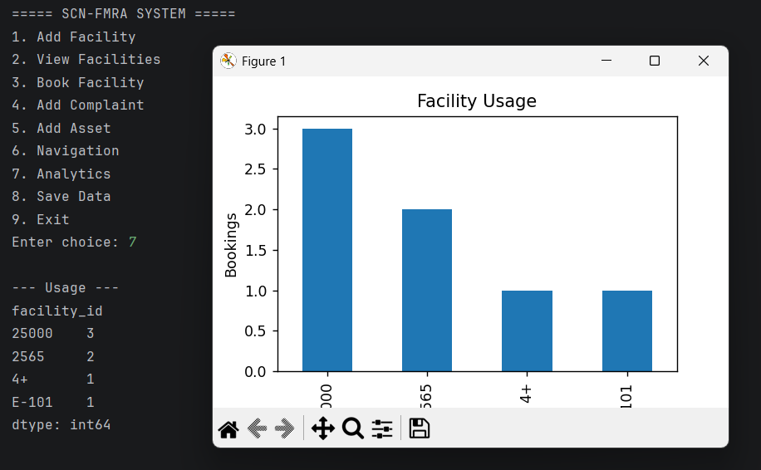

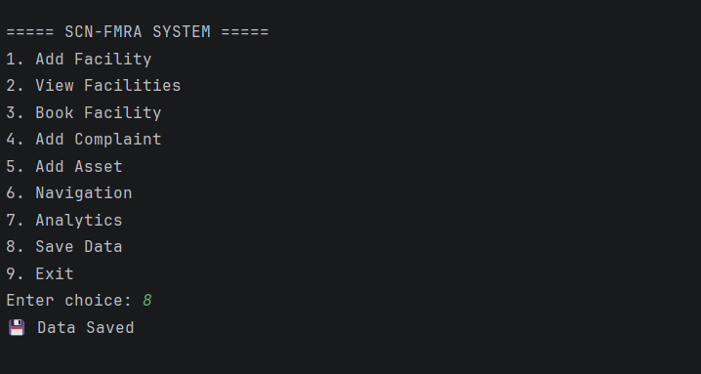

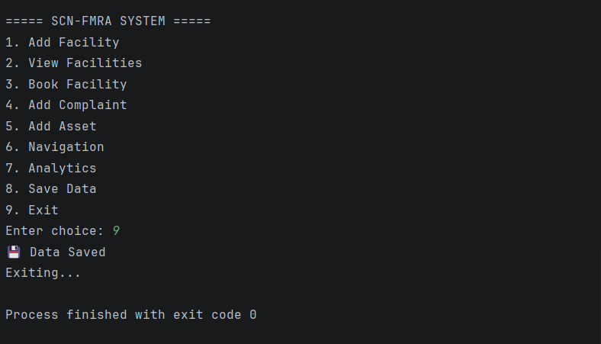

CONCLUSION

The SCN-FMRA system successfully demonstrates how Python can be used to build a real-world campus management solution. It integrates multiple functionalities such as navigation, facility booking, maintenance tracking, and analytics into a single system.

This project enhances problem-solving skills and provides practical exposure to software development concepts including data structures, object-oriented programming, file handling, and data analysis.
The system can be further improved with advanced technologies like AI, web development, and IoT, making it a strong foundation for future smart campus solutions.

